Lethal Dungeon: AI-Assisted Simulation and Balance Analysis
Korulein | Process evidence | 24 September 2026
The purpose of this document is to outline the work undertaken between the 21st and the 24th of September 2026, in which I used Claude to analyse Lethal Dungeon, a tile-based board game prototype, and to state plainly which parts of that work were mine and which were the model's. The work sits within Project Pipeline, my Semester 4 main project for our client InnerGames, whose assignment is a tool that estimates how long their games take to play. This session was not the deliverable itself but an initial investigation into what a language model is capable of when handed a rulebook, so that the findings could inform how the tool is built. I will divide the document into 5 sections as follows: the question I set out to explore, the division of work, the process, the outcome, and a comparison with a parallel attempt made by a fellow student.

1. What I set out to explore
Whilst human playtesting remains the authority on how a game feels at the table, sessions are expensive: four people, a table for the better part of an hour and a fresh setup each time. I wanted to establish whether a language model, given nothing but the rulebook and a single photograph of the prototype mid-session, could produce the sort of figures that normally take a dozen sessions to gather: playtime per turn and per round, loot and death rates, extraction times and the balance between the four player items. The secondary question, and the one I cared about more, was whether the same setup could be turned against the game to find exploits and loopholes before players find them for me.
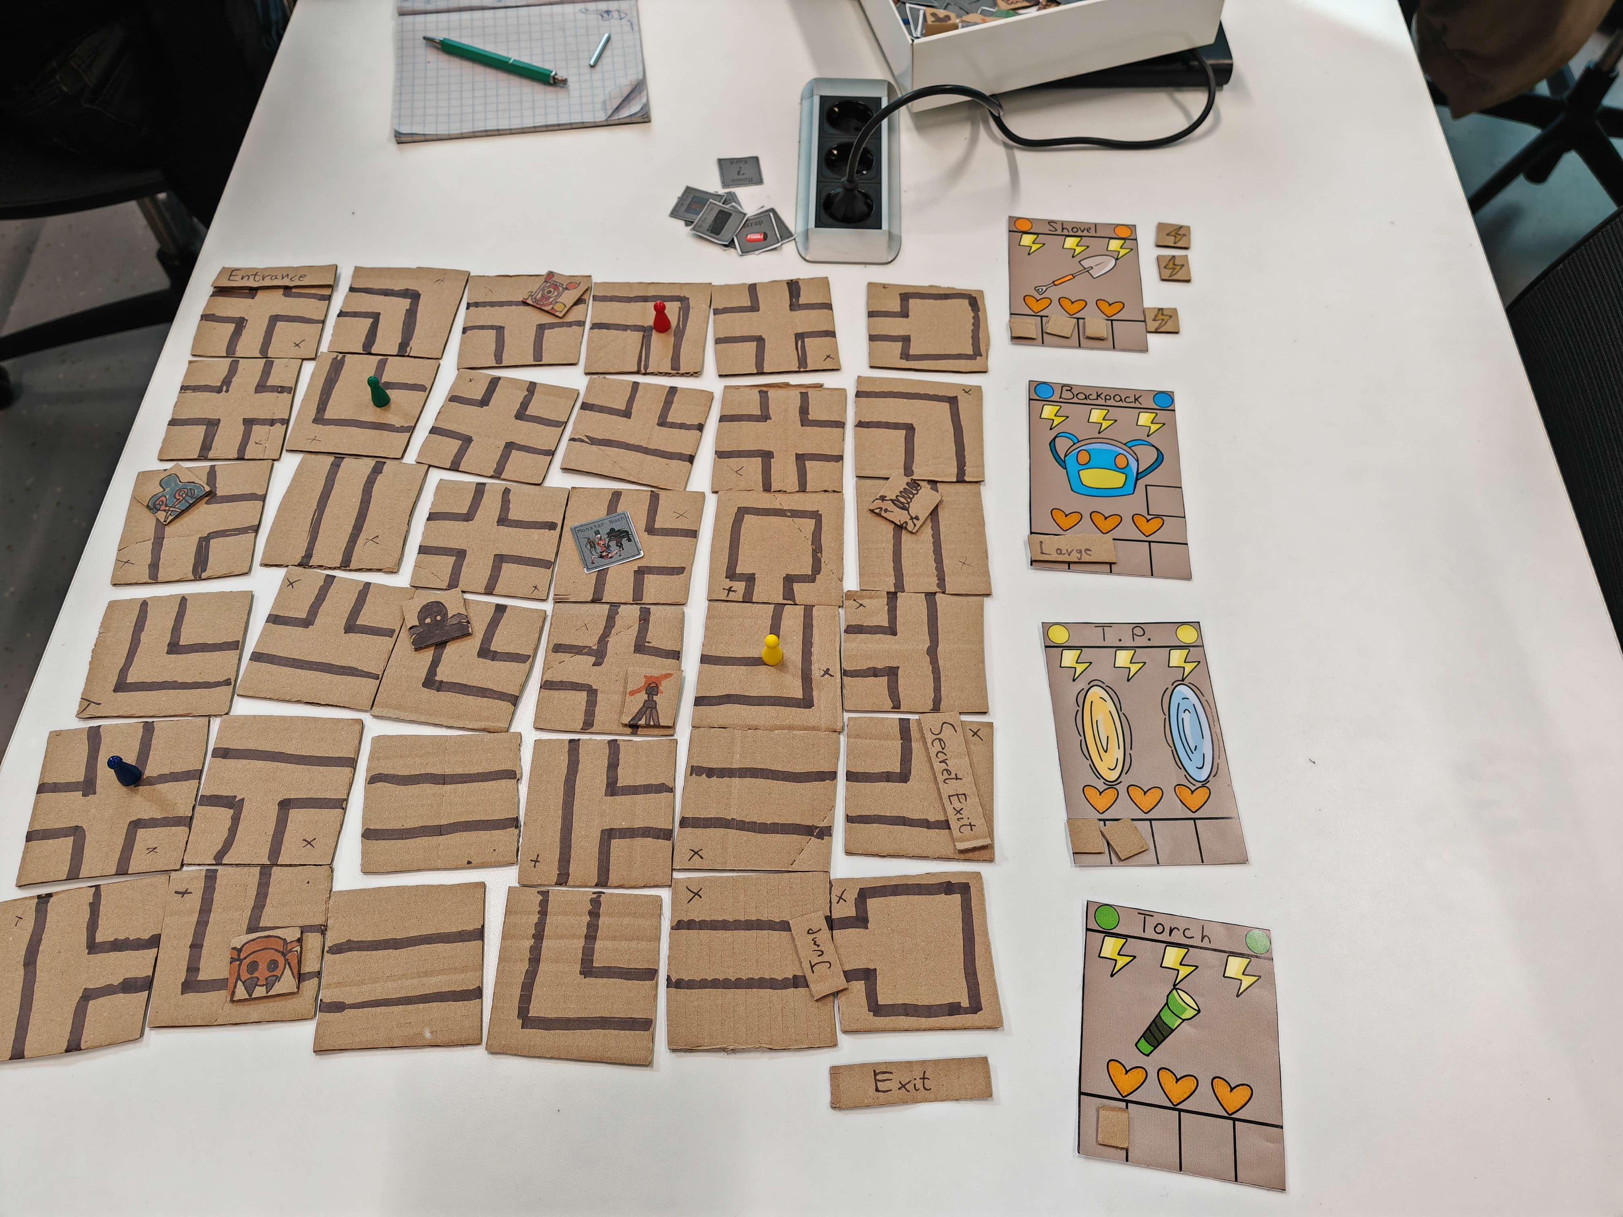
The Lethal Dungeon prototype mid-session. This photograph and the rulebook were the only material the model received.

2. How the work was divided
My own work:
- Supplied the material: the rulebook dated 18 September 2025 and a photograph of the prototype laid out on the table.
- Directed the process phase by phase and decided what happened next at every step.
- Confirmed or corrected the rule readings the model had guessed at, the 12 round game length being the most consequential of them.
- Interrogated the method: I asked why two abilities never appeared in the results and how the simulated players were making their decisions, which is what surfaced a fault in the model's code.
- Set the parameters for the later runs: full use of every ability, a weighting so that players path towards loot no opponent is nearer to, and permission to play cooperatively or spitefully whilst hunting exploits.
- Supplied the playtesting knowledge that contradicted the model's output, and judged which of its findings were worth keeping.
The model's work:
- Read the rulebook and the photograph into a structured dossier, with every uncertain reading flagged as such.
- Wrote the rules engine in Python, the simulated players and the timing model.
- Ran the simulations, close to 10,000 games across the four batches.
- Wrote the analysis, and admitted its own errors when questioned about them.
- Compiled the whole procedure into a reusable skill for the next prototype.
To be clear about the split: I did not write the code and I did not run the numbers. I supplied the material, directed the work, corrected the model where it was wrong and decided what the results meant.

3. The process
Phase 1, the Dossier. The rulebook and photograph were compressed into a machine readable breakdown of the rules, with no critique permitted at this stage, so that the game was recorded before it was judged. Eight points of ambiguity were listed separately as interpretations rather than faults, and a further six were added once the rules were turned into code.
Phase 2, the First simulation. One logged game was run as I had asked, alongside 2,000 further games that the model ran on its own initiative for context. That precaution proved worthwhile, since the single game turned out to be an outlier in which three players sat locked at the entrance for 5 rounds.
Phase 3, the Interrogation. I asked why the Shovel and Teleporter abilities never appeared. The answer was that no decision logic had been written for them, therefore they could never fire at all. The item comparison built on top of that was withdrawn, which is the part of this process I would point to as the reason for asking questions rather than accepting output.
Phase 4, Full ability use. The simulated players were rebuilt to plan their moves, use all eight abilities and time their exit runs, and 1,000 games were run on that basis.
Phase 5, Exploit hunting. Roughly 6,200 games were run in which one player used an exploiting strategy against three ordinary ones on identical setups, so that the gain from each strategy could be measured rather than guessed at.
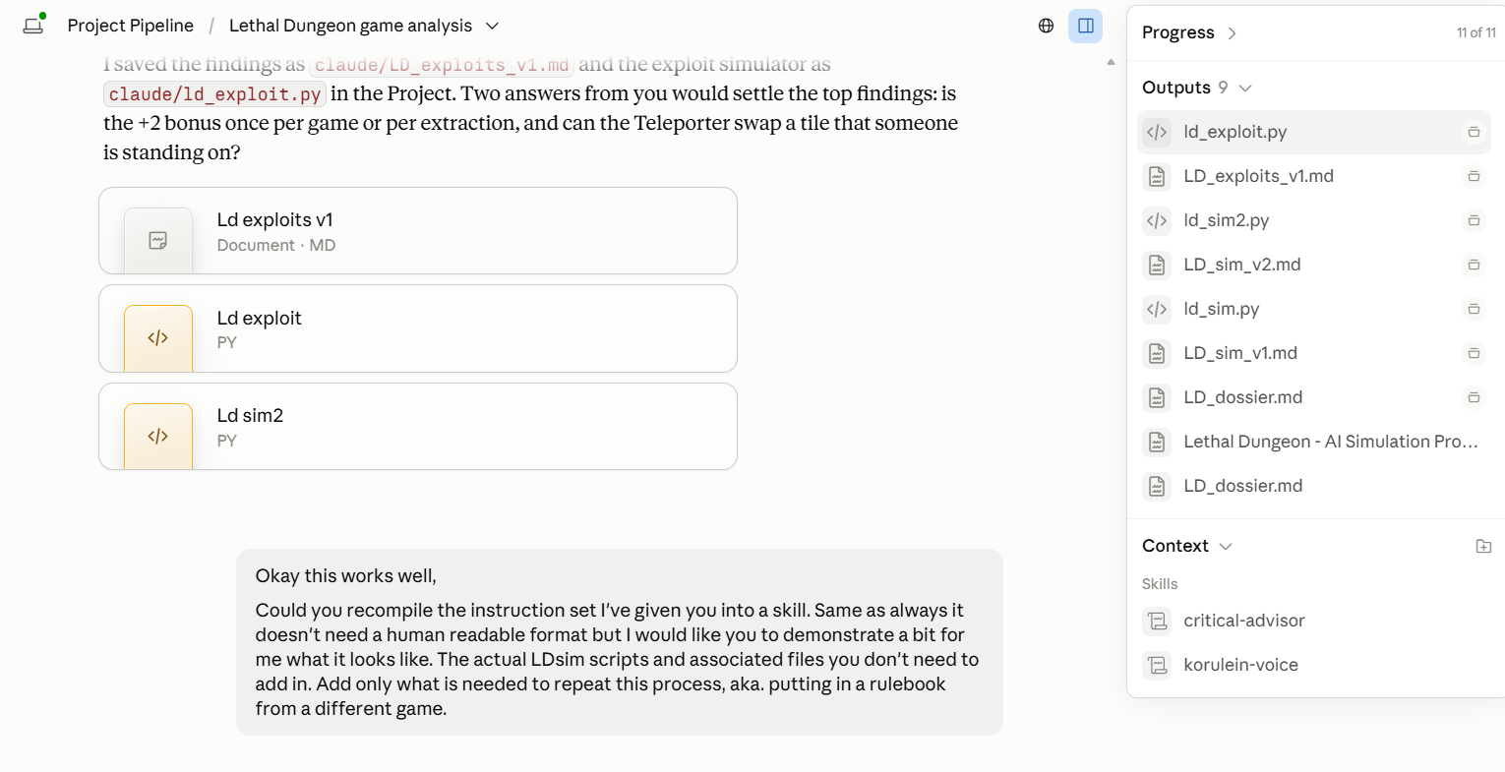
The working session, with each phase saved to the project workspace as it was completed.

4. What came out of it
- The extraction bonus can be farmed. The rulebook does not state whether the 2 point bonus is awarded once per game or once per extraction, and it does not require the player to be carrying anything. Under the second reading a player can step in and out of the entrance empty handed for 8 points a game, which beats the median winning score, without ever entering the dungeon.
- Spite pays. Attacking whoever is ahead costs the attacker around 0.2 points and costs the other three around 0.8 points each, raising the Shovel's win rate from 16 to 24 per cent.
- The Teleporter swap has no restriction against occupied tiles, unlike the Swap room card, which makes it an aimed teleport worth roughly a point a game.
- The items are uneven: the Torch wins 34 per cent of games and the Shovel 17, against 25 for an even split.
- In 13 per cent of games a player is locked on the entrance tile for 3 turns or more with no legal means of freeing themselves.
- A dozen points of wording were found to be ambiguous, including the timing of the Lightning Storm, the monster rule for empty handed players and the conflict between the rotation rule and the turn phases.
I will personally admit that these figures are only as good as the assumptions beneath them. The playtime estimates rest on a table of hand set action timings, the map was inferred from one photograph, and every simulated player is a set of heuristics rather than a competent human. The numbers are therefore leads to be tested at the table and not verdicts. The wording problems, however, sit in the rulebook itself and stand on their own.

5. Comparison with the parallel attempt
A fellow student ran the same investigation at the same time, and the two attempts differed in two respects worth recording. I wrote my own requirements and kept them short, whilst the other student supplied the full transcript of the client session as the brief. I also worked in steps, stopping after each phase to correct the model and set the next task, whilst the other student ran the whole thing in a single pass.
The results differed accordingly. My output was the plainer of the two and needed little translation before a person could read it, which I attribute to the simpler brief: a client transcript carries a great deal of noise alongside the requirements, and the model reproduces that noise in what it returns. The other student’s output was the more comprehensive of the two, and also the more obtuse. My run consumed considerably fewer tokens, since the stepwise approach only asks for the work that the previous step justified.
Whilst this is a comparison of two attempts rather than a controlled test, and neither of us held the other variables still, the pattern is pertinent to the tool we are building for InnerGames: a short, curated brief with a human checking each step produces something a client can read, and a full transcript in one pass produces something thorough that then has to be unpacked.

6. Further material
The game documentation, including the rulebook and the prototype material, is held here: https://drive.google.com/drive/folders/1ayWs1H0AgFD7bebJM5AtnrrOAQMeAd2o?usp=sharing

7. What I take from it
Next time I bring a prototype into this process, I will settle the ambiguous wording before the first simulation rather than after it, since every reading the model guesses at propagates into every number produced afterwards. I will also state upfront which abilities and strategies must be represented, having seen how convincingly a gap in the code presents itself as a property of the game.
Summary: Rulebook In / Dossier Built / 10,000 Games Run / 3 Exploits, 2 Balance Faults / Wording To Fix
Artefacts retained: the rules dossier, the simulation notes for both versions of the simulated players, the exploit findings, and the three Python scripts, all held in the project workspace.

